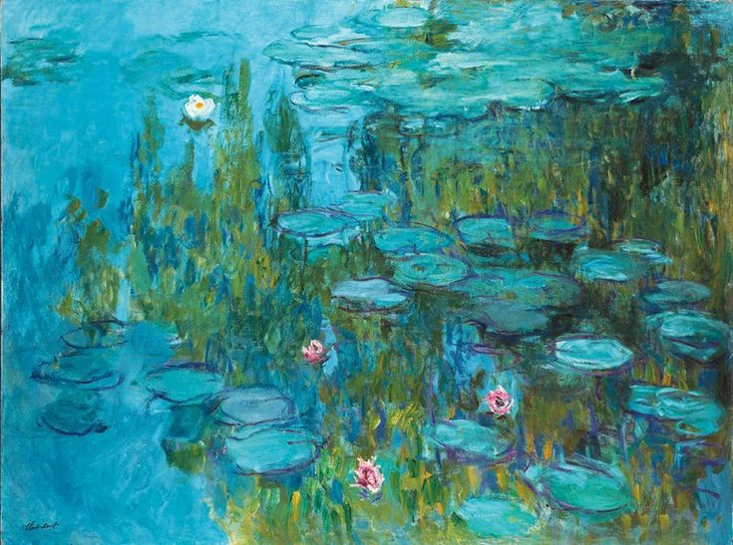

**First Baptist Church Covington Women’s Ministry**

2022 Fall/Early Winter Events

**Thursday, September 8th**

**Women’s Ministry Fellowship Game Night**

**6:00 pm -7:30 pm**

First Baptist Covington Commons

Bring appetizer to share

**Saturday, September 17th**

**Widow’s Meet/Greet**

**11:00 am -2:00 pm**

First Baptist Covington Commons

**Thursday-Saturday, September 22nd through September 24th**

**Heaven Rules Simulcast Conference**

Cross Point Baptist Church, Millington meet at First Baptist Covington

Cost $25

**Saturday, October 22nd**

**Prayer Breakfast/ Walk**

**8:30 am- 11:00 am**

First Baptist Covington Commons/Pond

Cost $5

**Friday, November 4th 6:00 through Saturday, November 5th 3:00pm**

Gathering Joyfully Overnight Retreat

The Grove in Cordova

Cost $65

Deposit $35 due September 24th

**Thursday, December 1st**

**Annual Women’s Christmas Dinner/Show**

**6:00 pm-9:00 pm**

Cost $15